RECIPE MANAGEMENT SYSTEM
@CREATIVITY THINK (9483175986/7019689991)

ABSTRACT:
Recipe Management System is a web-based platform designed to help users share, manage, and explore recipes efficiently. The system enables users to add, edit, categorize, rate, and comment on recipes while providing personalized dashboards and analytics. Administrators can moderate posts, manage categories, oversee ratings and comments, and generate insights using graphical dashboards. Developed with Django and Django Rest Framework for backend services and React with axios and recharts for frontend interactions, the system ensures organized recipe management, user engagement, and comprehensive administrative control..

INTRODUCTION OF THE PROJECT:
Traditional recipe sharing often occurs via blogs, social media, or scattered personal records, leading to disorganization, duplicate content, and lack of moderation. The Recipe Management System addresses these challenges by providing a structured platform where users can easily add, categorize, and interact with recipes. Real-time dashboards and analytics help track popular recipes, ratings, and engagement. Administrators gain control over content moderation, category management, and system-wide analytics. The platform promotes collaboration, transparency, and improved recipe discovery..

PROJECT OBJECTIVES:

• Provide a platform for users to share and manage recipes
• Allow users to search, rate, and comment on recipes
• Enable categorization and organization of recipe content
• Track user activity and engagement through dashboards
• Allow administrators to moderate content and manage categories
• Provide analytics on ratings, comments, and user interaction
• Ensure secure and scalable backend APIs
• Support exporting recipe data for personal use or reporting

PROBLEM OF THE STATEMENT:
Current recipe-sharing methods lack centralization, moderation, and analytics, making it difficult to manage content, track user engagement, and prevent duplication. Users struggle to save or export content efficiently, and administrators lack visibility into trends and user behavior. The Recipe Management System provides a digital solution with centralized data storage, content moderation, rating systems, dashboards, and export functionality to streamline recipe management and improve user experience..

MOTIVATION OF THE PROJECT:
• To create an organized platform for recipe sharing and management
• To enhance user engagement through ratings, comments, and dashboards
• To allow administrators to maintain quality content through moderation
• To provide data-driven insights on user interactions and content popularity
• To simplify saving and exporting recipes for personal or professional use
• To promote collaboration among food enthusiasts, families, and nutritionists
• To improve accessibility and discoverability of recipe content

BLOCK DAIGRAM OF PROJECT:

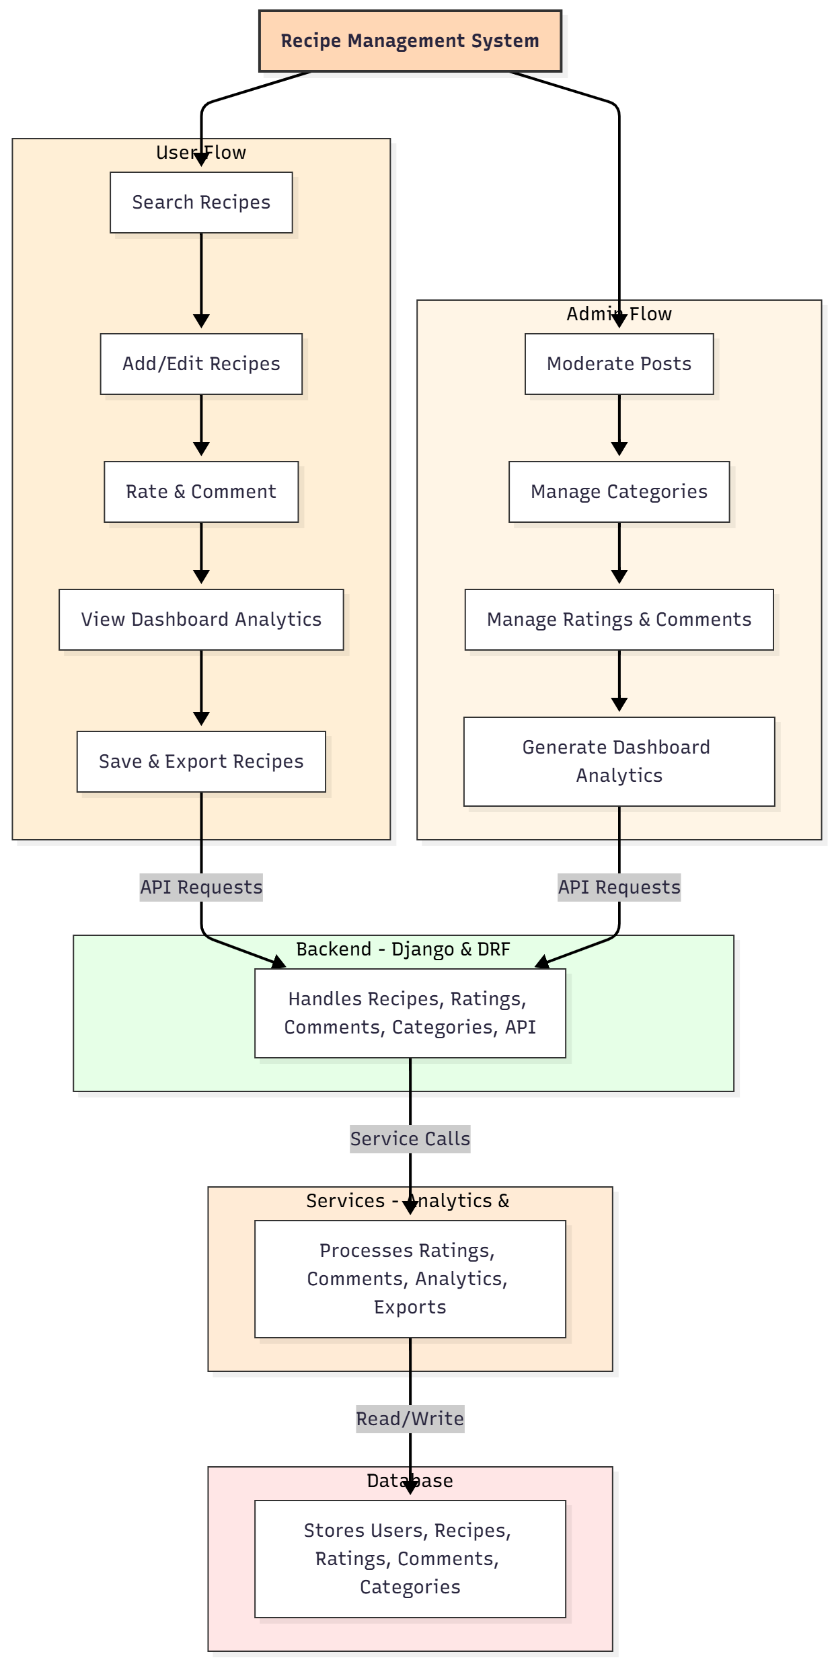

WORKING OF THE PROJECT:
Users can search and browse recipes, add or edit their own, and interact by rating and commenting. All interactions are stored securely in the backend. The dashboard provides insights into personal activity, popular recipes, and engagement trends. Administrators review content, moderate posts, manage categories, track ratings and comments, and generate analytics reports. The services module handles real-time processing of ratings, analytics, and export functionality. The database stores all user and recipe-related data, ensuring smooth operation, transparency, and data integrity..

SOFTWARE REQUIREMENT:
- Backend:
  - Python 3.x
  - Django
  - Django REST Framework
  - SQLite/PostgreSQL
- Frontend:
  - Node.js and npm
  - React.js
  - Axios
- Development Tools:
  - Visual Studio Code
  - Postman (for testing APIs)
  - Git/GitHub (for version control)
- Server/Deployment (Optional):
  - Gunicorn, Nginx, or Heroku/AWS for hosting

ADVANTAGES OF THE PROJECT:

• Centralized platform for managing and sharing recipes
• Supports ratings, comments, and content moderation
• Provides analytics dashboards for user and admin insights
• Easy saving and export of recipe data
• Reduces duplication and organizes content
• Improves engagement and discoverability of recipes
• Enhances collaboration among users
• Scalable and secure for personal or professional use

APPLICATIONS OF THE PROJECT:
• Food blogs and culinary websites
• Families managing personal or community recipes
• Nutritionists and diet planners
• Cooking communities and forums
• Educational platforms for culinary courses
• Recipe sharing and collaboration among chefs

REFERENCES:

- Django REST Framework Documentation — Django Software Foundation. Django Documentation. Available: https://docs.djangoproject.com/
- Django REST Framework. DRF Documentation. Available: https://www.django-rest-framework.org/
- React. React Official Documentation. Available: https://reactjs.org/docs/getting-started.html
- Redux. Redux Documentation. Available: https://redux.js.org/introduction/getting-started
- PostgreSQL Global Development Group. PostgreSQL Documentation. Available: https://www.postgresql.org/docs/
- MySQL. MySQL Reference Manual. Available: https://dev.mysql.com/doc/
- Git. Git Documentation. Available: https://git-scm.com/doc
- Node.js. Node.js Documentation. Available: https://nodejs.org/en/docs/
- Axios. Axios Documentation. Available: https://axios-http.com/docs/intro
- Socket.io Documentation – https://socket.io/docs/

